

CAPSTONE PROJECT REPORT
Report 3 – Software Requirement Specification

Ho Chi Minh City, 02 November 2026

Table of Contents
I. Record of Changes 3
II. Software Requirement Specification 3
1. Product Overview 3
1.1 Product Purpose and Context 3
1.2 Product Boundaries and Registered Capabilities 4
1.3 Users, Assumptions and Dependencies 4
1.4 Definitions 4
2. User Requirements 4
2.1 Actors 4
2.2 Use Cases 5
2.2.1 Use Case Diagram(s) 5
2.2.2 Use Case Descriptions 5
2.2.3 Main and Alternate Use-Case Flows 6
3. Functional Requirements 7
3.1 System Functional Overview 7
3.1.1 Screens Flow 7
3.1.2 Screen Descriptions 7
3.1.3 Screen Authorization 8
3.1.4 Non-Screen Functions 8
3.1.5 Entity Relationship Diagram 8
3.2 Account and Authentication System 9
3.3 Multiplayer Session and Lobby System 10
3.4 Game Design Specification – GDD (Game Projects) 11
3.4.1 Concept Overview 11
3.4.2 Story, Setting and Characters 11
3.4.3 Game Mechanics and Rules 11
3.4.4 Game Sections and Progression 12
3.4.5 In-game Resources and Economy 13
3.4.6 Rewards and Achievements 13
3.4.7 Characters, Items and Upgrades 13
3.4.8 Levels and Maps 13
3.4.9 Controls, Camera and HUD 14
3.4.10 Tutorial and Onboarding 15
3.4.11 Multiplayer and Social (if applicable) 15
3.4.12 AI and Difficulty 15
3.4.13 Monetization and In-app Purchases (if applicable) 16
3.4.14 Profile, Save Data and Live Operations 16
3.5 Player and Cooperative Gameplay System 16
3.6 Expedition Mission and Level Content 17
3.7 Stalker Monster AI System 17
3.8 Adaptive AI and Evaluation 18
3.9 Virtual Economy, Shop and Limited Administration 19
3.10 UI, Results and Data Logging 19
4. Non-Functional Requirements 20
4.1 External Interfaces 20
4.2 Quality Attributes 20
4.2.1 Usability 20
4.2.2 Reliability 21
4.2.3 Performance 21
4.2.4 Security, Data Integrity, Compatibility and Testability 21
4.2.5 Fairness and Security (Game Projects) 22
4.2.6 Compatibility and Localization (Game Projects) 22
5. Requirement Appendix 22
5.1 Business / Game Rules 22
5.2 Common Requirements and Validation Patterns 23
5.3 Application Messages List 23
5.4 Configuration and Acceptance Parameters 24
5.5 Registration-to-Requirement Traceability 24
5.6 Verification Criteria 25

I. Record of Changes
Date | A / M / D | In charge | Change Description
24 Oct 2026 | A | Đặng Huy Hoàng | Initial Report 3 SRS prepared from the proposed Review 2 registration, reflecting the single-Expedition scope and verifiable requirements.
27 Oct 2026 | M | Đặng Huy Hoàng | Aligned documented difficulty profiles, entity terminology, out-of-scope boundaries and non-Adaptive verification criteria with main. Adaptive AI requirements unchanged; no executed-test claims.
30 Oct 2026 | M | Lâm Thanh Phúc | LTP baseline; versioned Legal Agreements FR/UC/tests and data traceability added; 1–4 player scope unchanged.
31 Oct 2026 | M | Nguyễn Nhật Lệ Thuyên | Aligned FR/UC traceability, Legal Agreements and the source baseline; refined diagrams and reader-facing requirement structure.
02 Nov 2026 | M | ECHO PROTOCOL team | Aligned the updated game-specific faculty template with the existing GDD; added GDD Section 3.4, game quality attributes and visual cross-references; preserved existing FR IDs and acceptance status.

A = Added; M = Modified; D = Deleted.

II. Software Requirement Specification

1. Product Overview

1.1 Product Purpose and Context
ECHO PROTOCOL is a first-person cooperative survival-horror game for Windows 10/11 (64-bit). One to four players join a private host-controlled session, explore a single abandoned research facility, collect energy cores, restore designated power/security systems, complete cooperative tasks, evade one Stalker enemy, and attempt a valid evacuation. The gameplay experience must support both Win and Lose outcomes.
One player acts as session host and the remaining participants are clients. Photon Fusion synchronizes live player, item, enemy and mission state. An ASP.NET Core Web API hosted on AWS manages registered accounts, profiles, match results, rewards, ECHO Credits, shop purchases, item ownership and limited administration. Gameplay-authoritative decisions and backend-persistent records serve different responsibilities.
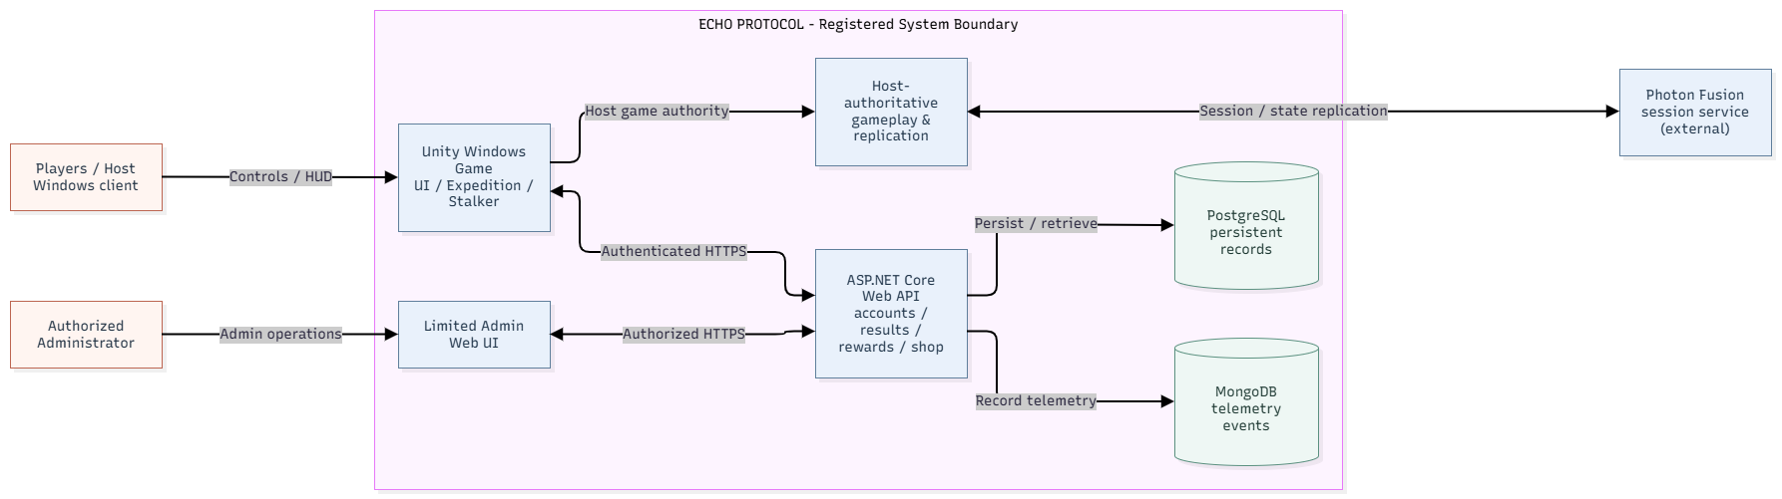
Figure 1. ECHO PROTOCOL system context and responsibility boundaries.
The integrated GDD in Section 3.4 is derived from the separate ECHO PROTOCOL Game Design Document, Revision 1.5 (31 October 2026). It is aligned to mandatory Expedition scope and the LTP design snapshot; test evidence and implementation completion are tracked separately from design requirements.

1.2 Product Boundaries and Registered Capabilities
AREA | REGISTERED EXPECTATION
Game client | One playable Research Facility Expedition with interaction, co-op and Win/Lose.
Cooperative gameplay | Movement, equipment/UV, noise, downed/revive, available assistance signals.
Enemy and adaptation | One Stalker with perception/state changes; at least one bounded adaptation; fixed fallback.
Economy and administration | Virtual-only ECHO Credits, validated match rewards, in-game shop/inventory and limited admin view/adjustments.
Evidence and quality | Fixed-versus-Adaptive comparison evidence, multiplayer and economy tests, reproducible FPS benchmark.
The registered Review 2 scope covers one Expedition in the Research Facility with one primary Stalker, multiplayer for 1–4 players, Adaptive AI with fixed fallback, account services, virtual ECHO Credits, shop and limited administration. Purge, additional maps/enemies, generative AI, advanced host migration, built-in voice chat, a separate player web portal, and real-money/payOS payments are outside the mandatory acceptance scope.

1.3 Users, Assumptions and Dependencies
Primary users are players who participate in private cooperative sessions; an eligible player also acts as host. Authorized administrators operate only the limited administration features. The design depends on supported Unity Windows builds, Photon Fusion sessions, an accessible AWS backend, approved game/AI configurations and network availability. The game must communicate session errors rather than silently treating invalid or disconnected states as successful.

1.4 Definitions
TERM | MEANING
Host authority | Session host validates authoritative gameplay state and outcomes.
Downed / Revive | A temporary incapacitated player state and valid teammate recovery action.
Fixed Baseline | A predefined non-adaptive configuration used when adaptive inputs are unavailable or for comparison.
Bounded Adaptive AI | Runtime decision constrained to explicitly configured safe parameter limits.
ECHO Credits | Virtual in-game currency; rewarded for validated matches or authorized test/admin allocations, not cash top-ups in scope.
Acceptance criteria | Objective observations/tests by which a specified requirement is passed or failed.

2. User Requirements

2.1 Actors
ACTOR | DESCRIPTION
Guest | User who has not authenticated; may reach registration/login but not private game/account operations.
Player | Authenticated person who views profile/shop/inventory, joins matches and plays Expedition.
Host Player | Authenticated player controlling private-room settings and authorized match start; also plays.
Administrator | Authorized operator of the limited admin interface for accounts, wallet/purchase records and permitted auditable adjustments.
Photon Fusion session service | External real-time networking service coordinating session connectivity; gameplay authority remains with host as defined in the registration.

2.2 Use Cases

2.2.1 Use Case Diagram(s)
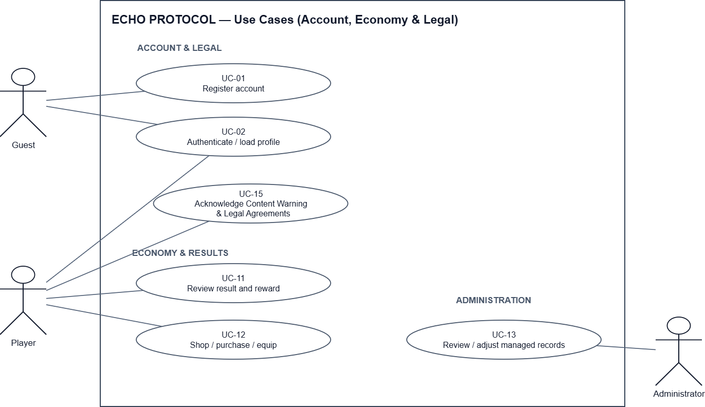

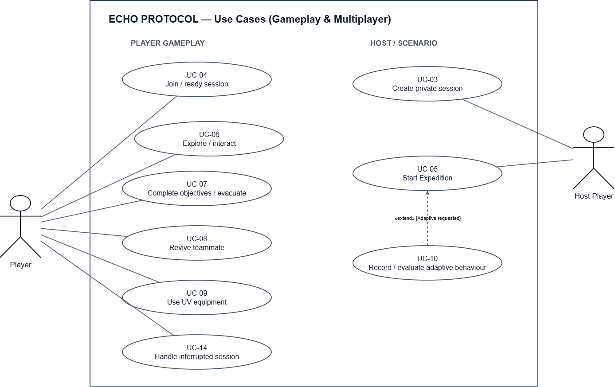
Figure 2. Use-case overview for player, host, administrator and system interactions.

2.2.2 Use Case Descriptions
ID | USE CASE | ACTORS | OUTCOME
UC-01 | Register account | Guest | Create an account and receive validation feedback.
UC-02 | Authenticate and load profile | Guest / Player | Log in, view own profile and progression; reject invalid access.
UC-03 | Create private session | Host Player | Select supported Expedition configuration and create a private room.
UC-04 | Join and ready session | Player | Join valid room, view participants, update ready state.
UC-05 | Start Expedition | Host Player | Start only as host with valid participants/configuration; load one mission.
UC-06 | Explore and interact | Player | Move, use equipment and interact with eligible objects.
UC-07 | Complete objectives and evacuate | Player / Host | Validate ordered mission goals and commit Win/Lose.
UC-08 | Revive teammate | Player | Consume required resource and restore only eligible Downed teammate.
UC-09 | Use UV equipment | Player | Use UV under eligible input and energy/cooldown rules; it does not stun or interrupt the Expedition Stalker.
UC-10 | Record and evaluate adaptive behaviour | Host system / Backend | Apply bounded change or fallback; retain decisions and metrics for evaluation.
UC-11 | Review match result and reward | Player / Backend | Display committed result and accepted reward exactly once.
UC-12 | Browse, purchase and equip item | Player / Backend | Validate cost/eligibility; grant ownership and apply equip rules.
UC-13 | View/adjust managed records | Administrator | Read permitted records and audit authorized wallet adjustments.
UC-14 | Handle interrupted session | Player / Host | Show reconnect/session-ended status without unauthorized completion.
UC-15 | Acknowledge Content Warning and Legal Agreements | Player | Display current terms; record all required declarations; refuse protected actions if unaccepted or stale.

2.2.3 Main and Alternate Use-Case Flows
UC-05 · Start Expedition
Main flow: Host selects an existing difficulty (Easy, Normal or Hard), verifies the registered 1–4-player lobby and issues Start. Session validates host authority and loads the same Research Facility mission on every accepted client.
Exception / alternate flow: Non-host Start is rejected; a participant with an invalid/failed join is not admitted; unrecoverable loading/session failure yields an error rather than a falsely active match.
UC-07 · Complete Objectives and Evacuate
Main flow: Team collects valid energy cores, performs configured power/security and cooperative prerequisites, then activates evacuation when all requirements are met. Host commits one Win result and sends the authoritative result to persistence.
Exception / alternate flow: Premature evacuation or duplicate objective execution cannot advance or commit result; failure state commits Lose under configured mission rules.
UC-08 · Revive Teammate
Main flow: Eligible teammate with required medical resource initiates revive on Downed player; host verifies range/state/resource/configured limits and applies successful revive once.
Exception / alternate flow: Invalid state, missing resource, interrupted revive or exhausted revive limit does not restore life or incorrectly consume resources.
UC-12 · Purchase Virtual Item
Main flow: Authenticated player browses server catalogue; submits item/price request; backend checks item validity, sufficient Credits and ownership rules, then atomically deducts credits and grants ownership; compatible items can be equipped.
Exception / alternate flow: Insufficient Credits, expired/invalid product, repeated request and unowned/incompatible equip are rejected without partial deduction or duplicate grant.

3. Functional Requirements

3.1 System Functional Overview
The system combines player-facing screens with host-authoritative gameplay functions and authenticated backend services. The following sections define the supported interfaces and functional responsibilities.

3.1.1 Screens Flow
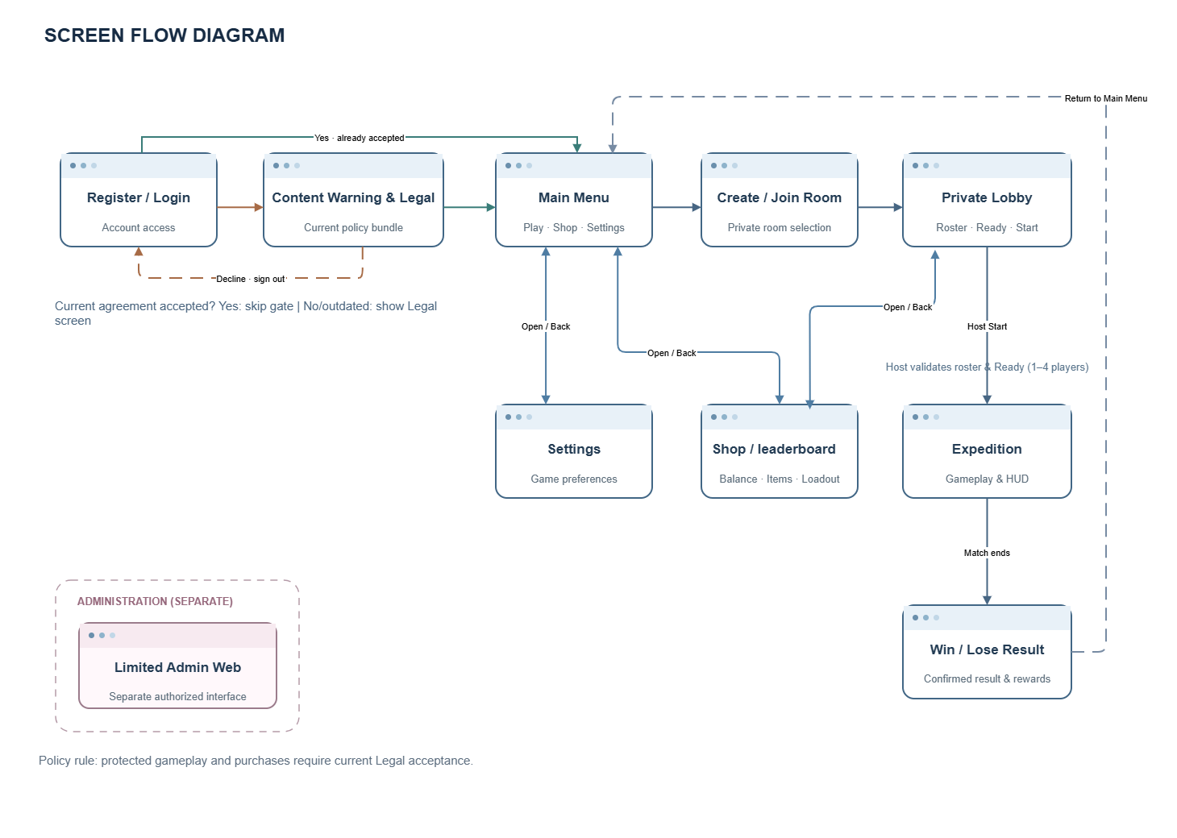
Figure 3. Game screen navigation and first-use agreement gate.

3.1.2 Screen Descriptions
SCREEN | FUNCTIONAL PURPOSE / DISPLAY
Register / Login | Account creation and authentication; validation errors and loading status.
Main Menu | Entry points to private room, shop, inventory and settings.
Create / Join Room | Host configures Expedition difficulty; client joins valid room information.
Private Lobby | Player identities, readiness, selected appearance, session and Host Start.
Expedition HUD | Context-relevant objective progress, interaction prompts, teammate status and UV/resource indicators.
Inventory / Shop | Owned items, compatible equips, catalogue, price, balance and purchase feedback.
Result | Win/Lose, progress, survival information, accepted Credits/XP and return navigation.
Settings | Supported game/display controls; actual configurable options follow the Windows build.
Limited Admin Web UI | Authorized user/wallet/purchase records and auditable permitted wallet changes.
Content Warning / Legal Agreements | Versioned first-use acknowledgement, adult declaration, privacy/community/transaction terms; blocking error if declined/outdated.

3.1.3 Screen Authorization
SCREEN / ACTION | GUEST | PLAYER | HOST | ADMIN
Register and log in | Yes | Yes | Yes | Yes
View own profile, inventory or shop | No | Yes | Yes | If authorized as player
Join private room / play Expedition | No | Yes | Yes | No admin privilege implied
Create a private room | No | Yes | Yes | No admin privilege implied
Choose difficulty / start hosted match | No | No | Yes | No admin privilege implied
View own results and rewards | No | Yes | Yes | No admin privilege implied
View permitted users, wallets, purchases | No | No | No | Yes
Perform auditable permitted wallet adjustment | No | No | No | Yes

A Host is a session role, not a global application administrator. Back-end permissions must be enforced server-side; hiding a control in the UI is not authorization.

3.1.4 Non-Screen Functions
FUNCTION | RESPONSIBILITY
Host-authoritative session replication | Validate player/objective/enemy/life/result actions and synchronize accepted state to peers.
Mission rules engine | Validate energy cores, power/security prerequisites, co-op interactions, evacuation gate, Win/Lose.
Stalker perception and behaviour | Consume allowed vision/noise/cue data, navigate, investigate, chase, attack and recover.
Adaptive AI engine | Read observed metrics; produce one or more bounded adjustments or fixed fallback with evidence.
Account and authorization API | Authenticate tokens, manage own profile and enforce privileges.
Match result and reward service | Validate committed outcomes, calculate configured rewards, deduplicate repeated results.
Virtual shop and wallet service | Validate product/price/balance/eligibility and apply atomic purchase/ownership changes.
Admin audit function | Permit authorized wallet adjustment with traceable records.
Persistence and telemetry | Save accounts, purchases, match outcomes, AI decisions and comparison metrics.

3.1.5 Entity Relationship Diagram
The diagram shows the principal account, economy, match and Adaptive AI data relationships. PostgreSQL stores persistent records, while Photon Fusion manages transient session states. Detailed keys and persistence constraints are specified in Report 4 (SDD).
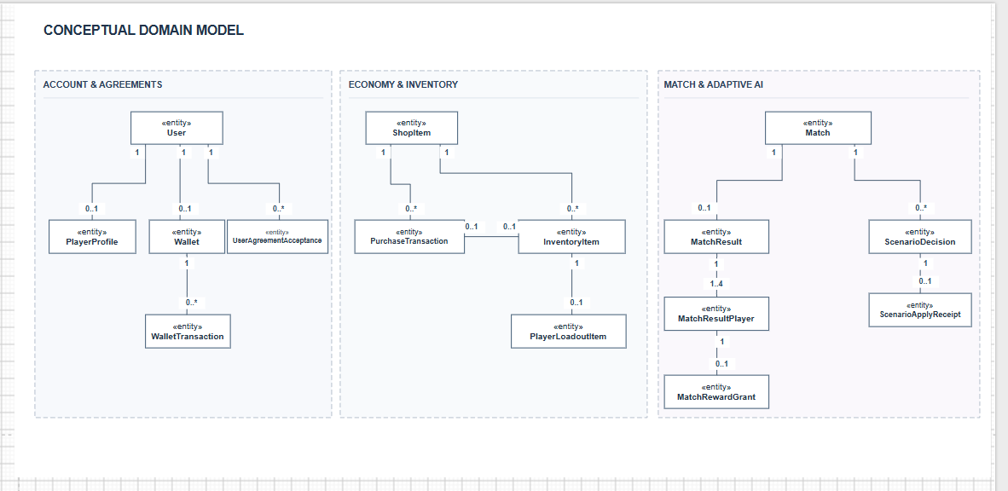
Figure 4. Conceptual relationships among persistent domain entities.
ENTITY | PURPOSE / INVARIANT
User / PlayerProfile | Registered identity, roles and profile/progression information (EF Core DbSets).
Wallet / WalletTransaction | Current virtual credit balance and auditable debit/credit history.
ShopItem / PurchaseTransaction | Server-approved catalogue and accepted purchase records, with replay safety.
InventoryItem / PlayerLoadoutItem | Owned items and equipped loadout mappings for an eligible player.
MatchResult / MatchResultPlayer / MatchRewardGrant | Host-validated match outcome, roster details and immutable reward records.
ScenarioDecision / ScenarioApplyReceipt | Persisted decision and apply evidence. Adaptive AI is not asserted complete in this revision.
UserAgreementAcceptance | Versioned per-player acknowledgements; user + bundle version, content hash and acceptance timestamp (PostgreSQL).

Player life state, active mission progress and Stalker state are host-authoritative runtime states rather than standalone persistent entities. Their transitions are described in the software design.

3.2 Account and Authentication System
After authentication, the player is presented with the current Content Warning and Legal Agreements when the required version has not been accepted. The system records the acceptance against the authenticated account. Match/scenario and protected purchase operations are rejected with AGREEMENT_REQUIRED until acceptance; invalid declarations or outdated document versions are rejected without creating an accepted record.
The following functional requirements specify observable success and rejection conditions. Unless otherwise stated, protected actions require authentication, an authorized session and current agreement acceptance.
FR ID | MANDATORY FUNCTION | ACCEPTANCE / NEGATIVE CASE | REG. AREA
FR-AUT-01 | Guest registers and authenticates; backend issues access only after valid credentials. | PASS: Valid credentials permit own session/profile; invalid credentials are rejected without protected data disclosure. | Account/Auth
FR-AUT-02 | Authenticated player can log out and retrieve only their own profile and progression. | PASS: Expired/invalid token or another user’s profile request is rejected. | Account/Auth
FR-AUT-03 | Player client loads server-accepted Credits balance, inventory ownership and selected customization. | PASS: Displayed data matches latest accepted server record after refresh; client-edited values cannot become authoritative. | Account/Auth
FR-AUT-04 | Backend hashes passwords, verifies access tokens and enforces role authorization on critical operations. | PASS: Unauthorized balance/ownership/reward/admin modifications are rejected server-side. | Account/Auth
FR-AUT-05 | Authenticated players must accept the current versioned Content Warning/Legal Agreements before protected gameplay/shop actions; acceptance is persisted per user and bundle version. | PASS: valid current acceptance enables protected actions; FAIL: missing/stale acceptance yields explicit rejection without side effect. | Account/Auth

3.3 Multiplayer Session and Lobby System
FR ID | MANDATORY FUNCTION | ACCEPTANCE / NEGATIVE CASE | REG. AREA
FR-MUL-01 | Host creates a private Expedition session supporting 1–4 active players (solo or cooperative) and selects an available difficulty. | PASS: a valid 1-, 2-, 3- or 4-player lobby can start through the authoritative Host; non-host participants must be Ready. Full/invalid room joins are rejected. | Lobby
FR-MUL-02 | Client joins using valid room information; invalid/full requests do not alter existing room state. | PASS: Invalid code/full room is refused with feedback; current connected participants remain unchanged. | Lobby
FR-MUL-03 | Lobby shows identity, ready state and host controls; only host may start. | PASS: Host-only start and required Ready states are checked for 1–4 participants; all accepted players enter the same Expedition. Solo Host start is a valid acceptance case. | Lobby
FR-MUL-04 | Host validates and synchronizes relevant player life, mission-objective, enemy and match states. | PASS: After accepted action, clients converge to same mission state; invalid client actions cannot commit state. | Lobby
FR-MUL-05 | Disconnect of client/host produces reconnect or session-ended feedback according to supported policy. | PASS: interrupted client/host obtains supported reconnect or session-ended status, no false result/reward commits. Exercise timeout and host-loss cases; no advanced host-migration success is mandatory. | Lobby

3.4 Game Design Specification – GDD (Game Projects)
This section integrates the existing ECHO PROTOCOL Game Design Document (GDD, Review 2 edition) into the faculty game-project SRS format. Game rules describe the mandatory Research Facility Expedition; values are current LTP design references, not claims that every gameplay or end-to-end test has passed. The standalone GDD remains the extended design and illustration reference.

3.4.1 Concept Overview
ECHO PROTOCOL is a first-person cooperative survival-horror game for Windows 10/11 (64-bit), developed with Unity. One player may play solo as Host, or 2–4 players may cooperate in a private Host-authoritative session. The mandatory deliverable is one Research Facility Expedition comprising three connected objective zones and one primary Stalker. Players recover Energy Cores, restore security systems, escort and charge the Spacefrigate, then attempt evacuation. The session ends with a validated Win or Lose; backend confirmation governs persistent rewards and virtual ECHO Credits.
Game design property | Mandatory Review 2 design
Official title / genre | ECHO PROTOCOL / first-person cooperative survival horror
Players / platform | 1–4 in a private room; Windows 10/11 64-bit; keyboard and mouse
Playable modes / maps | One mandatory Expedition in one Research Facility; three gameplay zones
Threat / balance | One Stalker with six behavioural states; Easy, Normal, Hard and bounded Adaptive AI with Fixed Fallback
Virtual economy | Earn/spend ECHO Credits through validated backend transactions; no mandatory real-money purchases
Optional implementations | Purge, payOS sandbox, Player Web Portal and built-in voice chat are outside mandatory acceptance
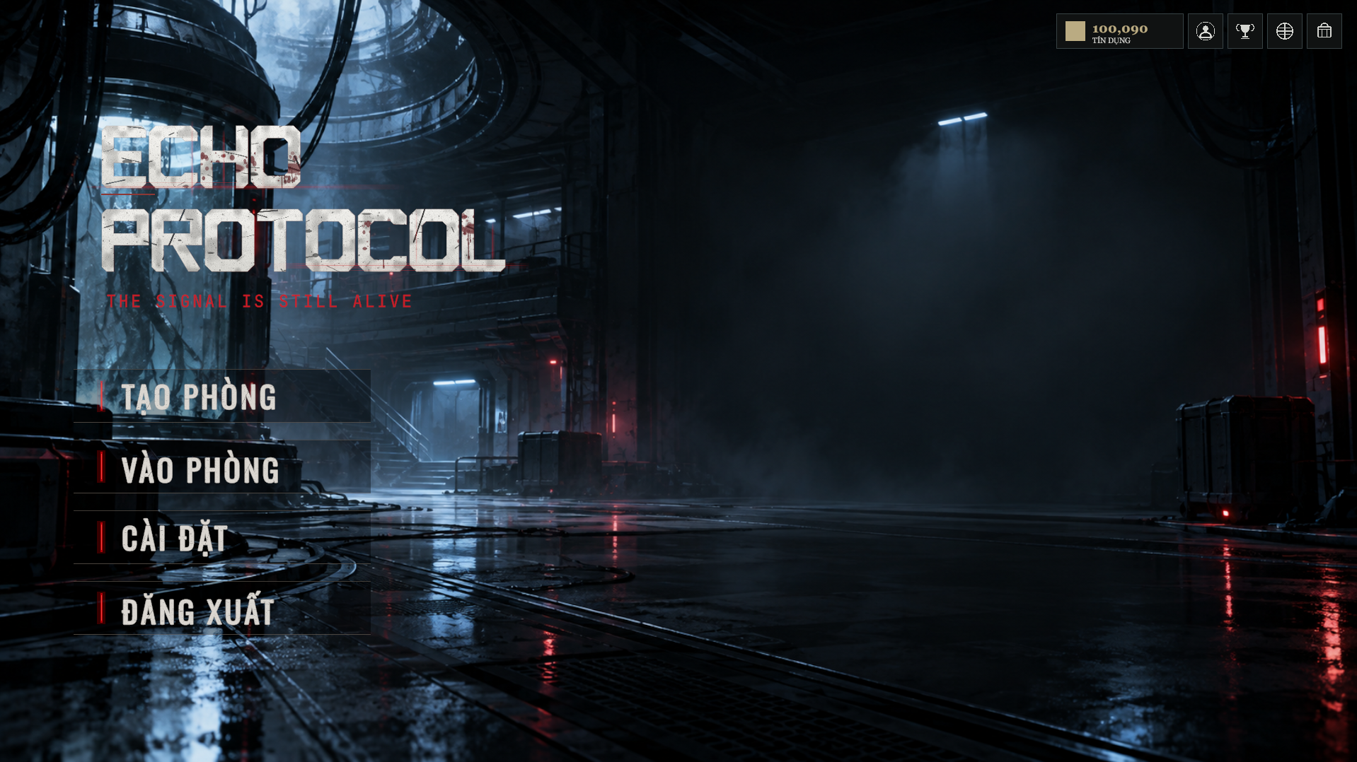
GDD Figure 2 (reused). Actual ECHO PROTOCOL main-menu screenshot; game presentation reference.

3.4.2 Story, Setting and Characters
Players enter an abandoned and hazardous high-technology Research Facility to recover resources and restore the ability to evacuate. Environmental storytelling comes from deteriorated machinery, security terminals, relays, warnings and restricted sightlines; cinematic cutscenes or branching dialogue are not required for the registered mode. The player is a survivor/explorer using equipment and teamwork rather than combat progression. The Stalker is the primary hostile creature, sensing visible players and eligible noise, investigating cues and pursuing valid targets. Its behaviour is authoritative in the live match. Purge creatures and flooded residential content are separate extensions, not mandatory Expedition cast or environments.

3.4.3 Game Mechanics and Rules
Players move, sprint, crouch, use a flashlight/UV device, interact with objectives, carry and deposit resources, select permitted team equipment, and attempt teammate revives with First Aid when eligible. Objective gates, enemy damage, life-state changes and escape are validated by Host-authoritative gameplay. UV consumes configured energy but does not stun, repel or interrupt the Expedition Stalker. Success is finalized if at least one eligible player escapes under the authoritative end conditions; otherwise the match ends in Lose. A solo player can finish all mandatory mission stages without teammate-only interactions.
Rule | Specification / source-aligned reference
Life state | Alive → Downed → Revived Alive or Eliminated; eligible players may Escaped; Caught is a separate mode-dependent shared state.
Revive | First Aid required; source GDD references 3-second interaction, up to 3 m, 180-second base bleedout and difficulty-dependent per-zone budget.
Core gate | Zone 1: collect four Energy Cores and deposit two into each of two Sector Boxes.
Host authority | Client requests never directly award Win, mission progression, item ownership or wallet balance.
Reward safety | Result and reward state remain Pending/Unavailable until backend confirmation; retries must not duplicate grants.

3.4.4 Game Sections and Progression
Stage | Required actions | Progression gate
Lobby / Pre-match | Authenticate, meet current agreement requirement, create/join room, select difficulty and ready up | Host-authorized match start; 1–4 players
Zone 1 – Recovery | Collect 4 cores; deposit 2 per Sector Box | Both boxes complete
Zone 2 – Security | Discover Security Terminal; repair A1/A2/B1/B2; complete Security Hold; validate access code/panels | Authorized zone access accepted
Zone 3 – Frigate | Find and escort Spacefrigate; replenish Fuel Cells as needed; charge at dock | Charge/mission prerequisites accepted
Final Hunt / Exit | Survive escalation, unlock evacuation and interact with the final exit | Authoritative escape and match finalization
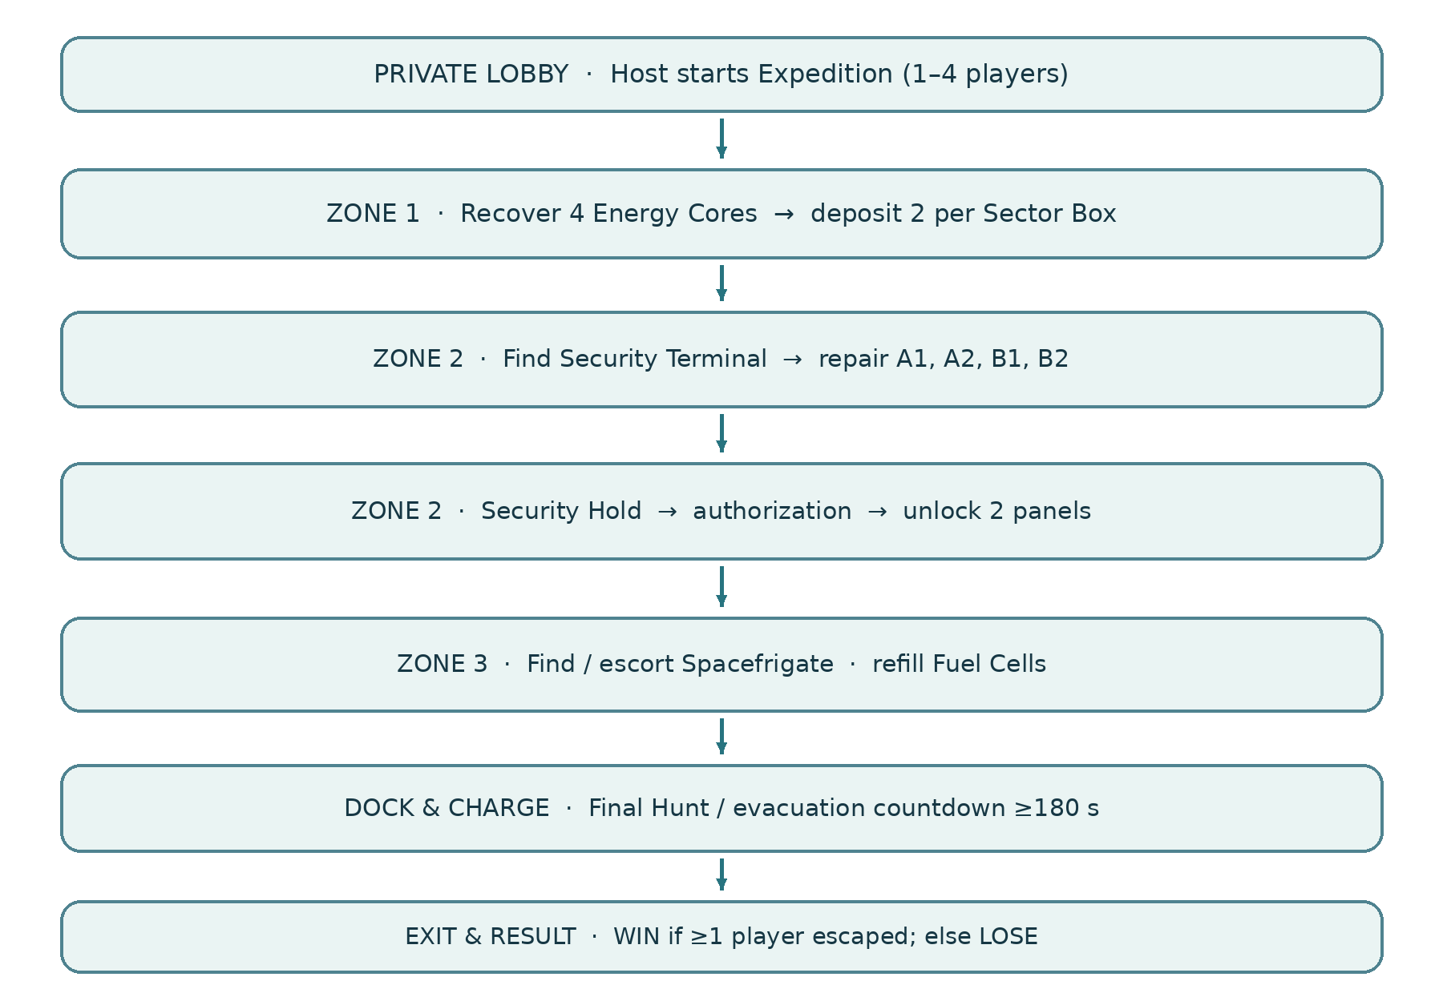
GDD Figure 3 (reused). Expedition objective sequence and progression gates.

3.4.5 In-game Resources and Economy
Resource | Acquisition and use | Authority / balance
ECHO Credits | Validated rewards or permitted administrative/test grants; buy authorized virtual items | Backend wallet, transaction and purchase records
XP / Level | Earn after accepted match and approved progression calculation | Backend player profile; no client-awarded XP
Energy Cores | World mission objects recovered and deposited during Zone 1 | Host mission objective state; not a cash/shop currency
Fuel Cells | Objective resources used during the Zone 3 frigate escort/refill sequence | Host gameplay state
UV Energy | Held equipment activation drains resource; regeneration follows configured timer | UV never interrupts Expedition Stalker
First Aid / support tools | Use only when eligible; supplies vary by difficulty/configuration | Host validates availability, revive eligibility and consumption
Starting wallet balance, shop prices and reward amounts are governed by the active backend configuration/catalogue and are not hard-coded in this GDD. No real-money top-up, platform IAP, advertisements or premium tiers are required for mandatory Review 2.

3.4.6 Rewards and Achievements
The primary reward source is a validated Expedition match outcome. After a permitted Host submits the roster and result, backend services validate the match, determine eligible Credits/XP rewards, record transactions and return confirmed data for the Result screen. Repeated or replayed submissions must not cause multiple grants. The approved reward policy may consider participation, objectives, survival, Win/Lose and contribution, subject to the deployed configuration. A standalone achievement, daily-login, event-gift or leaderboard reward system is not a mandatory requirement.

3.4.7 Characters, Items and Upgrades
Lobby presentation may show existing character/cosmetic selections and owned items. Current supporting tool examples include First Aid, Field Scanner, Noise Maker, Door Jammer and Core Stabilizer as exposed by the active catalogue and configured gameplay. Carryable mission resources and persistent purchased inventory must remain separate. Only server-owned item records authorize purchases and equipment. No tier-based weapon upgrade, pay-to-win power system or competitive matchmaking rating is required.
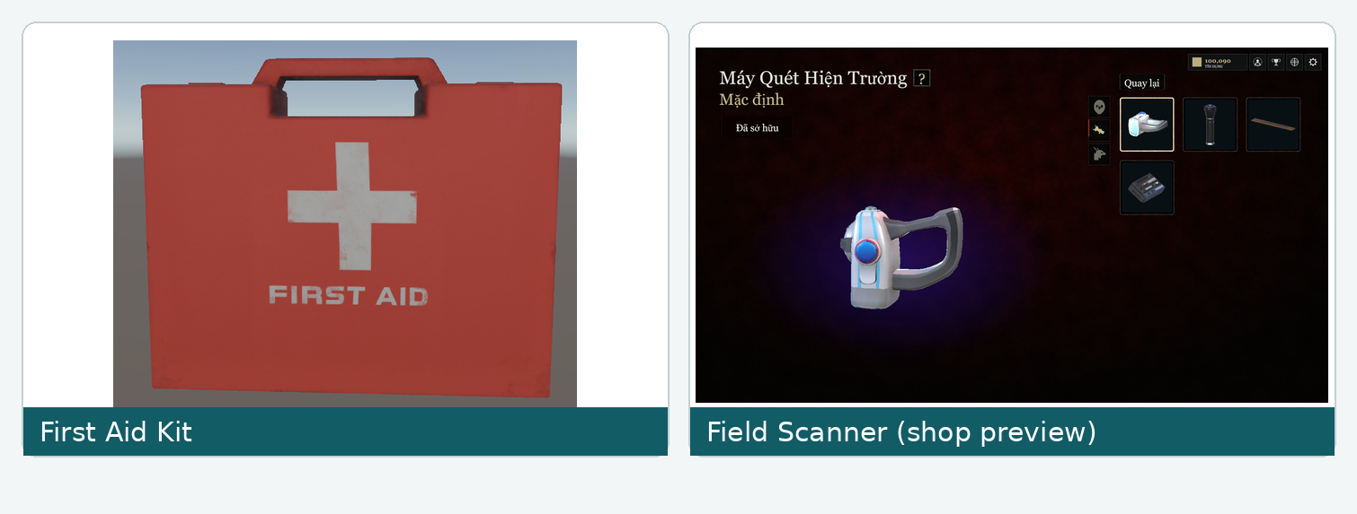
GDD Figure 6 (reused). First Aid and Field Scanner asset/UI references.

3.4.8 Levels and Maps
The one mandatory Research Facility is arranged as three sequential gameplay zones. Zone 1 introduces core recovery and sector power; Zone 2 introduces security terminal, relay repair, Security Hold and distribution authorization; Zone 3 contains frigate escort/fuel, dock charge and evacuation. Readable interactables, safe spawn/navigation and Stalker pathing must preserve valid solo and cooperative mission completion. The floorplan below is a conceptual overview; exact room-to-zone boundaries, spawn positions and exit coordinates must be verified in Unity scene data before being labelled.
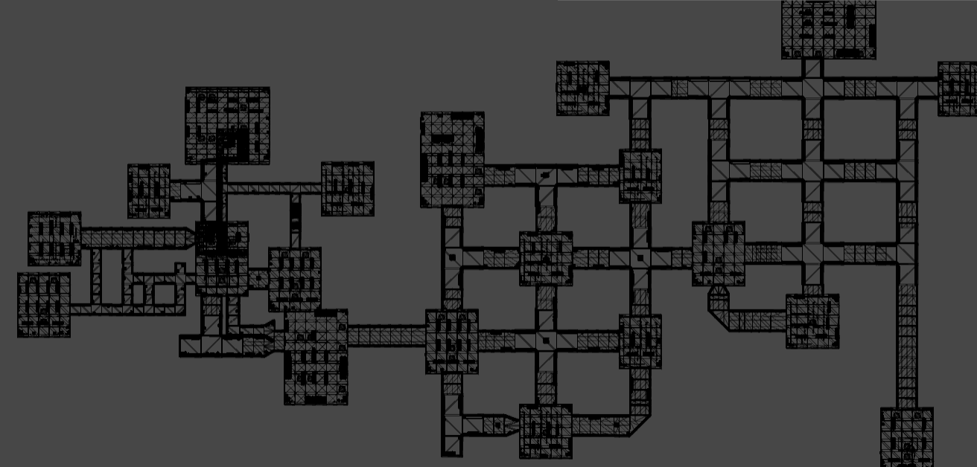
GDD Figure 7 (reused). Research Facility level overview; conceptual mission layout.
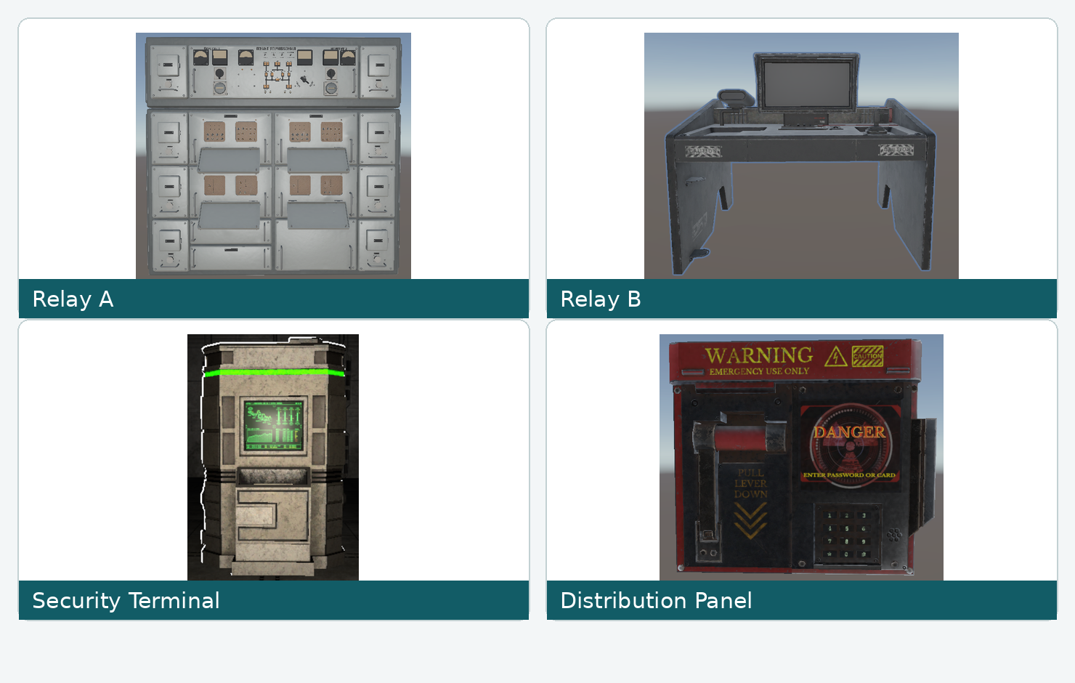
GDD Figure 9 (reused). Zone 2 relay, terminal and distribution-panel visual references.

3.4.9 Controls, Camera and HUD
The game uses a first-person keyboard/mouse camera. Default input bindings in the inspected LTP settings source are W/A/S/D movement, E interaction, Left Shift sprint, C crouch, F flashlight and Tab inventory; mouse camera settings and remapping are local preferences. UV has a separate contextual/hold control in the GDD, subject to actual gameplay binding. The HUD shows objective status, valid interaction prompts, health/Downed status, teammate state, equipment/UV energy and contextual danger; a live multiplayer pause/settings overlay does not pause the Host simulation.
HUD element | Display condition / content
Mission tracker | Current accepted objective or phase, with progress as needed
Interaction prompt | Only when valid target/context exists, including rejection reason if available
Team status | Lobby or co-op context, especially Downed/Eliminated/Escaped
Equipment/UV | When selected, active, resource-critical or cooldown-relevant
Danger feedback | Event-triggered; short damage vignette/shake or threat warning without obscuring objectives
Result and Credits | After match resolution; Credits only when backend confirmed
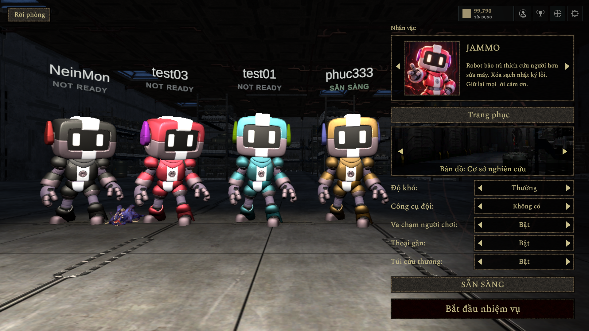
GDD Figure 5 (reused). Four-player lobby example and gameplay settings presentation.

3.4.10 Tutorial and Onboarding
Onboarding is contextual rather than a separately promised full tutorial campaign. An initial login presents the current Content Warning and Legal Agreements when required; backend acceptance is versioned and protected actions remain blocked until current acceptance exists. Gameplay help teaches essential interaction rules in a practical order: movement and camera; interaction prompts; carrying/depositing cores; objectives and security terminals; UV resource limitations; and co-op support/revive eligibility. Each prompt should correspond to an action that actually exists in the tested build. Full skip/replay controls and tutorial-completion telemetry are not claimed without verification.
Onboarding moment | Guidance / completion signal
First protected access | Accept current agreement bundle; server confirms current-version acceptance
Facility entry | Show movement/camera and interaction controls; successful eligible interaction
Core recovery | Show valid pickup and accepted Sector Box deposit
Security objectives | Show terminal/relay prerequisites and accepted state
Stalker encounter | Explain threat through sensory cues, not a mandatory UV stun counter
Downed teammate | Explain First Aid eligibility and successful or rejected revive outcomes

3.4.11 Multiplayer and Social (if applicable)
Online play supports private Host sessions of 1–4 active participants, with solo Host mode. A non-host participant must be Ready where the lobby rule requires it; only the Host starts and mutates authoritative mission state. Photon Fusion synchronizes roster, player actions, objective progress, Stalker state and life state. On invalid joins or connection failures, the client should display a supported rejection or session-ended status. Full in-match reconnect and advanced Host migration are not mandatory or assumed complete. Public competitive matchmaking, ranked MMR, social-network invitations, push notifications and mandatory voice chat are outside registered Review 2 acceptance.

3.4.12 AI and Difficulty
The primary Stalker uses PATROL, DETECT, CHASE, ATTACK, RECOVER and SEARCH. Vision can accumulate detection toward pursuit; sound/last-known-position cues can trigger investigation. Attack outcomes are Host-authoritative. Difficulty is a fixed starting profile, distinct from the bounded Adaptive Experience Director (AED). Source profiles and current GDD values are summarized below; these are configuration references, not executed acceptance results.
Profile | Patrol speed | Chase speed | Detection time | Max revives / zone
Easy | 5.0 | 5.0 | 2.00 s | 4
Normal | 6.5 | 7.5 | 1.25 s | 3
Hard | 8.0 | 9.0 | 0.75 s | 2
The guarded pre-match Adaptive AI policy may use approved Survival and Noise observations to select bounded parameters, such as SupportItemBudget (0, 1 or 2) or ChaseSpeed (9, 10 or 11), when supported by valid policy/evidence. Missing or invalid inputs yield a Fixed Fallback. The inspected AED runtime configuration keeps gameplay activation disabled by default. Controlled Fixed-versus-Adaptive evidence is a separate evaluation obligation, not implied by source availability.
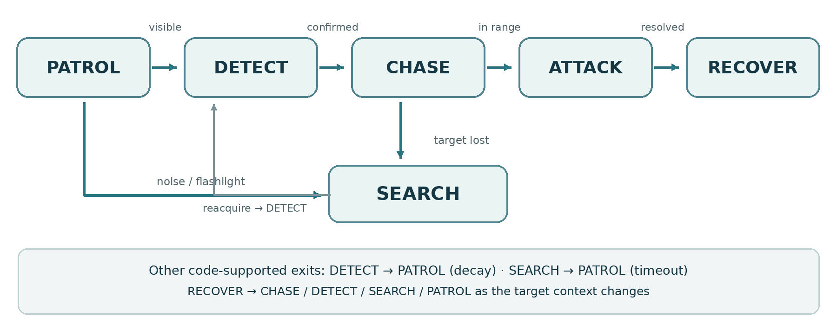
GDD Figure 13 (reused). Stalker six-state behaviour model.

3.4.13 Monetization and In-app Purchases (if applicable)
The mandatory business model is a non-cash virtual ECHO Credits economy: players earn approved Credits, view the server catalogue, purchase eligible items and receive backend-owned inventory. The client cannot set price, balance, ownership or reward authority. The repository also contains a separate Player Web Portal and payOS sandbox integration, which are documented as implemented extensions outside mandatory Review 2 acceptance. No production IAP, payment store, premium tier, advertisements or cash spending obligation is claimed here.

3.4.14 Profile, Save Data and Live Operations
The backend persists account and profile identity, XP/progression, match results, wallet transactions, inventory ownership and required agreement acceptance. PostgreSQL manages transactional player/economy state; MongoDB supports gameplay telemetry. Host/Photon Fusion state such as player position, temporary objective flags, Stalker target and match timers is session state, not a client-owned durable save. Windows local preferences (controls, graphics, language and audio) use PlayerPrefs where implemented. Backend database migrations and repository-controlled Unity assets govern schema/content revisions; a standalone cloud-save conflict-merge system is not required. Limited administration supports authorized account/economy inspection and approved auditable adjustments. Daily live events, inbox campaigns, competitive seasons or customer-care platform features are outside mandatory acceptance.

3.5 Player and Cooperative Gameplay System
FR ID | MANDATORY FUNCTION | ACCEPTANCE / NEGATIVE CASE | REG. AREA
FR-PLY-01 | Player can walk, sprint, crouch, interact, carry defined items, activate UV and use available assistance signals. | PASS: Eligible actions work in match; unavailable/invalid actions leave authoritative state unchanged. | Player
FR-PLY-02 | Noise from configured movements/interactions is available to Stalker perception. | PASS: Valid noise can trigger Stalker response; silent/ineligible actions do not fabricate noise events. | Player/AI
FR-PLY-03 | A player can transition into a Downed state under legitimate Stalker attacks and may be eliminated under match rules. | PASS: All peers observe authoritative life-state outcome; no duplicate damage changes committed state twice. | Player
FR-PLY-04 | Teammate with required medical resource can revive eligible Downed player within configured limitations. | PASS: Valid revive restores player once; missing item, wrong state or exceeded rule cannot revive. | Player
FR-PLY-05 | Equipment, inventory and item interactions respect ownership/eligibility and session authority. | PASS: Item cannot be reused, spawned or equipped by an unauthorized state or non-owner. | Player/Shop

3.6 Expedition Mission and Level Content
FR ID | MANDATORY FUNCTION | ACCEPTANCE / NEGATIVE CASE | REG. AREA
FR-EXP-01 | The Unity game client shall load the mandatory Research Facility Expedition level containing three mission zones, objective interaction points, and evacuation locations. The Player initiates participation through a valid match session, while the Host-authoritative match system controls mission progression and objective availability. | PASS: The packaged Windows build loads the Research Facility level in a valid solo or multiplayer session. All three mission zones and their required interaction points are accessible under the configured gameplay prerequisites. Objective interactions remain unavailable when their prerequisites are not satisfied. Level-loading failures must not be reported as successful match entry. | Expedition
FR-EXP-02 | Players collect required energy cores and restore designated power/security systems subject to prerequisites. | PASS: Accepted objectives advance in correct sequence; absent resources/prerequisites prevent advancement. | Expedition
FR-EXP-03 | Configured cooperative interactions must be completed as prerequisites before evacuation is unlocked. | PASS: Host rejects premature activation; accepted co-op progress appears consistently on connected clients. | Expedition
FR-EXP-04 | Mission interface communicates current objectives and eligible interactions. | PASS: HUD reflects host-accepted objective state and updates after prerequisite completion. | Expedition/UI
FR-EXP-05 | Expedition shall commit Win only after prerequisites and valid evacuation; otherwise defined Lose condition may terminate. | PASS: evacuation is accepted only after prerequisites, Host commits one Win/Lose outcome, and Backend accepts/replays one result identity without duplicate reward; test invalid early exit and repeated submission. | Expedition/Result

3.7 Stalker Monster AI System
FR ID | MANDATORY FUNCTION | ACCEPTANCE / NEGATIVE CASE | REG. AREA
FR-AI-01 | One primary Stalker uses the six source states PATROL, DETECT, CHASE, ATTACK, RECOVER and SEARCH; visual detection and noise cues cause only valid state transitions. | PASS: Behaviour transitions occur on valid stimuli; after losing target Stalker returns to search/patrol. | Stalker
FR-AI-02 | Stalker detection uses observable vision, noise and recent encounter cues; no unrestricted hidden-player location knowledge. | PASS: Occlusion/no-cue test avoids instant illicit detection; valid sight or noise can initiate detection. | Stalker
FR-AI-03 | Attack effects on players, including Downed state, must be host-authoritative. | PASS: Invalid/duplicate client reports do not create damage or life-state corruption. | Stalker/Host
FR-AI-04 | UV equipment use obeys configured energy, targeting and input rules. The Expedition Stalker is not stunned, repelled or interrupted by UV. | PASS: valid UV activation consumes/recharges energy as configured without changing Stalker pursuit; invalid/depleted activation is rejected. | Stalker/Player
FR-AI-05 | The Host-authoritative Stalker AI shall navigate the required accessible areas of the Research Facility and respond to valid perception and gameplay stimuli without an unrecoverable navigation or pathfinding failure that blocks mandatory Expedition progression. | PASS: In documented gameplay test cases covering the mandatory Expedition route, no unrecoverable NavMesh, pathfinding, or navigation deadlock prevents required objective progression or evacuation. Valid perception stimuli produce the expected AI response. Any blocking defect must be recorded with the scene or zone, position, AI state, reproduction steps, and observed result. A reproducible blocking navigation failure causes the corresponding test case to fail. | Stalker/Expedition

3.8 Adaptive AI and Evaluation
FR ID | MANDATORY FUNCTION | ACCEPTANCE / NEGATIVE CASE | REG. AREA
FR-ADA-01 | System records supported observed player/team gameplay metrics as inputs to Adaptive AI. | PASS: Valid observed metrics have reproducible match linkage; missing inputs are flagged. | Adaptive
FR-ADA-02 | When inputs and configuration are valid, at least one gameplay parameter may be adjusted within configured min/max bounds. | PASS: Test produces an applied decision inside the configured range; out-of-bounds value is never used. | Adaptive
FR-ADA-03 | Missing, invalid or insufficient metrics must select a fixed-baseline fallback instead of an unvalidated adaptation. | PASS: Invalid-input test returns fixed settings and records fallback reason. | Adaptive
FR-ADA-04 | Each evaluated fixed/adaptive run records match identity, mode, selected adjustment or fallback and outcome metrics. | PASS: Logs permit matching and checking comparable runs without claiming untested effectiveness. | Adaptive/Eval
FR-ADA-05 | The QA/Evaluation Team shall perform and document repeatable Fixed-versus-Adaptive AI comparison tests using the mandatory Expedition scenario. Each comparison shall identify the tested configuration, observed player/team metrics, applied bounded adaptation or Fixed Fallback, gameplay outcomes, and associated execution evidence.  This requirement concerns evaluation deliverables and system verification rather than a direct Player gameplay interaction. | PASS: At least one controlled Fixed-versus-Adaptive comparison is documented with a Fixed run and an Adaptive run under stated comparable test conditions.  The evaluation record identifies the source commit, test environment, player count, scenario configuration, observed input metrics, applied AI decision or Fixed Fallback, outcome metrics, and supporting execution evidence.  Missing test runs, incomplete comparisons, or unavailable execution evidence must be reported as NOT VERIFIED and must not be presented as successful evaluation results. | Adaptive/Eval

3.9 Virtual Economy, Shop and Limited Administration
FR ID | MANDATORY FUNCTION | ACCEPTANCE / NEGATIVE CASE | REG. AREA
FR-ECO-01 | Game shop displays backend catalogue, item price, description, owned status and server Credits balance. | PASS: Catalogue/balance match authorized API response; UI cannot override price. | Shop
FR-ECO-02 | Authenticated player purchases eligible item only with sufficient ECHO Credits after server-side product, balance and ownership checks. | PASS: Valid purchase succeeds; insufficient, invalid or ineligible request fails without partial effects. | Shop
FR-ECO-03 | Each successful purchase deducts Credits and grants ownership atomically. | PASS: Repeated requests never grant duplicate ownership or debit more than accepted purchase. | Shop
FR-ECO-04 | Player views inventory and equips only owned, compatible supported customization/equipment. | PASS: Unowned/incompatible item is rejected; accepted equip reflects server record. | Shop
FR-ECO-05 | Validated Expedition result produces a configured Credits/XP reward through server-verifiable outcome submission. | PASS: verified Expedition match outcome is accepted from authorized Host, resulting Credits/XP appear only after server confirmation; replay/duplicate submissions never grant an additional reward. | Reward
FR-ECO-06 | Authorized administrator may view user, wallet and purchase records, and make permitted auditable wallet adjustments. | PASS: Unauthorized access blocked; valid adjustment records actor, target and change. | Administration

Administration and Item Ownership Responsibility
- The registered item ownership management capability is implemented through the authenticated Shop and Inventory backend services. Successful purchases grant item ownership through server-side validation and persistent transactions, as specified in FR-ECO-02 and FR-ECO-03.
- The Limited Administration interface provides authorized access to user, wallet, and purchase records and supports permitted, auditable wallet adjustments under FR-ECO-06. Direct administrative granting, revocation, or modification of inventory ownership is not included in the mandatory Review 2 administration functions.
- This separation clarifies the responsibility of the existing registered shop, inventory, and administration components without introducing additional administrative privileges.

3.10 UI, Results and Data Logging
FR ID | MANDATORY FUNCTION | ACCEPTANCE / NEGATIVE CASE | REG. AREA
FR-UI-01 | Windows client provides authentication, main menu, private lobby, Expedition HUD, settings, shop, inventory and result view. | PASS: All registered screens reachable by eligible role and valid navigation. | UI
FR-UI-02 | HUD shows context-relevant objectives, teammate life state, prompts, mission items, UV/resources and evacuation status. | PASS: Indicators update from authoritative state and do not display completed objectives as pending. | UI
FR-UI-03 | Result view displays Win/Lose, mission progress, survival information and accepted rewards after completion. | PASS: result view differentiates pending, accepted and rejected/temporarily unavailable Backend reward; no locally estimated Credits/XP are shown as confirmed. Compare to result and reward API records. | UI/Result
FR-UI-04 | Backend persists authorized accounts, progression, wallets, purchases, inventory, match results and AI evaluation records. | PASS: Records retrievable by authorized scope; sensitive data not exposed to unrelated user. | Data
FR-UI-05 | The game client shall provide distinguishable and actionable feedback for invalid input, rejected lobby or objective interactions, authorization failures, interrupted network sessions, and rejected virtual shop purchases. Feedback shall reflect the actual accepted or rejected system state rather than implying successful completion of a failed operation. | PASS: Every defined negative UI test case displays an appropriate error, rejection, pending, or session-ended status. Failed operations do not produce unauthorized state changes, false success confirmations, or incorrectly committed purchases or rewards. When supported, the user can retry the operation; otherwise, the interface provides an available safe navigation or session-ended outcome. Test cases shall cover invalid input, denied interaction, interrupted connectivity, and rejected purchases. | UI

4. Non-Functional Requirements

4.1 External Interfaces
INTERFACE | REQUIREMENT / BOUNDARY
Unity Windows Client ↔ Photon Fusion | Game sessions must provide host-authoritative real-time state; no advanced host migration commitment.
Unity Client ↔ ASP.NET Core Web API | Authenticated HTTPS/REST communication for profiles, results, Credits, shop and inventory.
ASP.NET Core Backend ↔ Persistent Storage | Persist validated game/economy data; backup and recovery to be verified in test environment.
Admin Web Interface ↔ Backend | Limited authorized records and wallet adjustments; no mandatory shop-product CRUD.
Player Input/Display | Windows 10/11 64-bit, 1920×1080 Low preset; keyboard/mouse and configured display UI.
Excluded external interfaces | payOS, commercial payment processor and separate player-facing web portal not needed for registered acceptance.

4.2 Quality Attributes
The quality requirements below specify measurable targets for the registered Windows game and its supporting services.

4.2.1 Usability
Interface messages and gameplay HUD elements shall reflect the latest accepted game or backend state. The usability acceptance target is that 100% of the defined negative UI test cases provide a distinguishable and accurate failure, pending, or unavailable-state indication without falsely reporting success.
Verification shall use a documented UI test set covering invalid login, invalid or unavailable lobby entry, denied objective interaction, rejected virtual shop purchase, and authorization failure. For each test case, the evaluator shall record the input or trigger, expected feedback, actual displayed status, resulting system state, and Pass/Fail outcome. A test fails if the interface reports success for a rejected operation or provides no identifiable feedback for a required failure case.

4.2.2 Reliability
The system shall preserve authoritative match and persistent transaction consistency under defined failure and replay conditions. The reliability acceptance targets are zero duplicated committed rewards or item grants, zero negative wallet balances caused by invalid or repeated transactions, and 100% accurate session-status feedback in the defined supported network-interruption test cases.
Verification shall include repeated match-result and reward submissions, repeated or rejected purchase requests, and supported client-disconnection scenarios. Backend records shall be compared before and after each replay attempt to detect duplicate grants or inconsistent balances. Network tests shall verify that the client displays an accurate reconnecting, disconnected, or session-ended state according to implemented capabilities. Seamless host migration and guaranteed mid-match reconnection are outside mandatory Review 2 acceptance unless independently demonstrated and approved. All test outcomes shall be recorded as PASS, FAIL, BLOCKED, or NOT RUN with supporting evidence.

4.2.3 Performance
Target minimum PC configuration: Intel Core i5-8400 or AMD Ryzen 5 2600, 16 GB RAM, GTX 1060 6 GB or RX 580 8 GB, and 15 GB SSD storage. Recommended configuration: Intel Core i5-10400F or Ryzen 5 3600, 16 GB RAM, GTX 1660 SUPER 6 GB or RX 5600 XT 6 GB, and SSD storage. Windows 10/11 64-bit and broadband network connectivity are required. Performance acceptance is defined by NFR-01 and NFR-06.

4.2.4 Security, Data Integrity, Compatibility and Testability
ID | ATTRIBUTE | METRIC / TARGET | VERIFICATION METHOD
NFR-01 | Performance | Average rendered FPS · ≥30 FPS | Record FPS/frame time using a 15-minute representative Expedition session on the target Windows build at 1920×1080 Low. A separate 29 October four-player 50.02 FPS capture used preset PC, not Low; report results by their actual preset.
NFR-02 | Capacity & sync | Connected participants and authoritative match-state divergence · 1–4 participants; zero conflicting final objective/result states | Create/join/play with 1, 2, 3 and 4 participants; compare Host/client mission and result at synchronization checkpoints.
NFR-03 | Transaction integrity | Invalid/repeated economy requests causing duplicate credit/grant or negative balance · Zero duplicate reward/item grant or negative balance in rejection/replay test set | Backend/API tests: insufficient balance, duplicate purchase, replayed match result, invalid wallet operation.
NFR-04 | Security | Unauthorized successful access to protected resources · Zero unauthorized operations in defined negative authorization suite | Use unauthorized and role-mismatched tokens against own/other profiles, shop, wallets and admin endpoints; record HTTP/result evidence.
NFR-05 | Persistence & recovery | Recovery integrity of designated persistent data records. Acceptance threshold: 100% of the predefined validation sample records are successfully restored with zero detected integrity mismatches, and authorized access to the restored data is verified. Backup and restore durations and the observed recovery point shall be recorded. Formal production RPO/RTO guarantees are not committed within the mandatory Review 2 scope. | Perform a documented PostgreSQL backup-and-restore rehearsal in an isolated AWS test environment. Before backup, define and record representative sample records and expected values from the required persistent data categories. Restore the backup, compare record counts, identifiers, critical values, and relevant relationships against the predefined samples, and verify authorized data access. Record the execution date, environment, source backup, restore duration, observed recovery point, comparison results, and PASS/FAIL status. Missing or inconsistent required sample records cause the recovery rehearsal to fail.
NFR-06 | Windows compatibility | Supported OS/graphics configuration · Windows 10/11 64-bit; 1920×1080 Low preset | Launch packaged build, select target display preset, complete representative session; record hardware and OS.

4.2.5 Fairness and Security (Game Projects)
The Host validates mission progression, objective interactions, Stalker decisions and player life-state transitions; clients cannot directly finalize gameplay state. Backend authorization and transaction invariants protect account data, Credits, purchases, inventory and reward grants. Failed interactions must not award benefits. The Expedition does not include competitive MMR, pay-to-win upgrades or an authorized client-side debug cheat in a release build. Validate negative cases for non-host start, invalid inventory use, duplicate reward/purchase and unauthorized wallet adjustment.

4.2.6 Compatibility and Localization (Game Projects)
The deliverable targets Windows 10/11 64-bit on the tested keyboard/mouse hardware envelope. Player options include local graphics, resolution/performance settings, audio levels, configurable controls and Vietnamese/English UI selection where supported by the LTP settings source. Text, fonts, fallback glyphs and UI layout must be checked in both languages, including Vietnamese diacritics. The representative FPS target and exact test preset remain those documented in NFR-01; a different measured preset must be labelled accurately.

5. Requirement Appendix

5.1 Business / Game Rules
ID | RULE DEFINITION
BR-01 | The only mandatory playable mode and location are Expedition and the abandoned Research Facility.
BR-02 | Committed Expedition participation is 1–4, including solo Host. Non-host members must be Ready; only the Host can start.
BR-03 | Host-authoritative state governs player life, objectives, Stalker effects and committed outcome.
BR-04 | Evacuation remains locked until all configured required objectives are complete.
BR-05 | A mission ends in one committed Win or Lose according to configured match rules.
BR-06 | Revive requires an eligible teammate, valid Downed target, medical resource and configured limits.
BR-07 | Stalker detection depends on observable cues. UV equipment consumes resources but does not interrupt the Expedition Stalker by design.
BR-08 | Adaptive AI modifies at least one selected parameter only inside declared minimum/maximum; invalid input uses Fixed Fallback.
BR-09 | Results/rewards are server-validated; repeated accepted match identifier cannot award twice.
BR-10 | ECHO Credits are virtual-only in scope; no real-money purchases or payOS top-ups are mandatory.
BR-11 | Shop purchases check availability, ownership and balance; deduction + ownership update is atomic.
BR-12 | Administrator access is restricted and wallet adjustments must be auditable; broad product CRUD is not required.
BR-13 | Unowned/incompatible items cannot be equipped.
BR-14 | No additional map, Purge, independent enemy, voice chat or separate Player Web Portal is required for acceptance.
BR-15 | Protected match/scenario/shop actions require recorded acceptance of the current policy bundle for the authenticated user; no acceptance means an explicit authorization-style rejection.

5.2 Common Requirements and Validation Patterns
PATTERN | REQUIRED BEHAVIOUR
Unauthorized or malformed request | Reject without modifying protected state; provide appropriate error feedback.
Idempotent result/reward requests | Repeated submission does not issue an additional result or grant.
Race conditions / replay of purchase | Deduction and ownership must remain atomic and consistent.
Network disconnect | Client sees accurate reconnect/ended state; do not fabricate match success.
Config-dependent limits | Use approved difficulty/revive/UV/AI bounds from tested configuration; no hard-coded values assumed in SRS.
Defect evidence | Each negative test must include preconditions, observed state/log, expected outcome and owner.

5.3 Application Messages List
CODE | TYPE | CONTEXT | PROPOSED MESSAGE / MEANING
MSG-01 | Error | Login | Invalid credentials or expired session. Please sign in again.
MSG-02 | Error | Private room | Room unavailable, invalid, or full.
MSG-03 | Information | Lobby | Only the host can start the match.
MSG-04 | Information | Connectivity | Connection interrupted. Reconnecting or ending session.
MSG-05 | Prompt | Objective | Complete the required objectives before evacuation.
MSG-06 | Feedback | Revive | Revive is unavailable under current conditions.
MSG-07 | Warning | UV equipment | UV cannot be used: check energy, range, or cooldown.
MSG-08 | Result | Match | Expedition complete. Result: Win / Lose.
MSG-09 | Error | Shop | Insufficient ECHO Credits.
MSG-10 | Error | Shop | Item unavailable or already owned.
MSG-11 | Feedback | Inventory | Only compatible owned items can be equipped.
MSG-12 | Result | Rewards | Reward granted / not yet verified.
MSG-13 | Error | Account | You are not authorized to perform this action.
MSG-14 | Result | Administration | Wallet adjustment recorded.

Messages describe required feedback; exact wording may vary by localization.

5.4 Configuration and Acceptance Parameters
TOPIC | CONFIGURATION / DESIGN BASIS | ACCEPTANCE CONDITION
Difficulty levels | Three difficulty profiles: Easy, Normal and Hard. | Each selectable difficulty must map to the supported Research Facility game configuration; verify differences in AI and revive settings.
Energy core / objective counts | Research Facility Expedition uses energy-core, power/security and evacuation prerequisites across its three zones. | The match follows the configured objective sequence. Evacuation is unavailable before required prerequisites are complete.
Revive limits | Revive uses an eligible Downed target, First Aid and defined range/time/budget rules. Source difficulty budgets: Easy 4, Normal 3, Hard 2 per zone. | Check eligibility, resource consumption, interruption, valid/invalid states and the selected difficulty budget in a Windows multiplayer build.
UV equipment boundaries | UV operates with energy, range and cooldown limits; it does not affect Expedition Stalker pursuit. | Verify resource feedback and unchanged Stalker pursuit during valid UV activation; reject invalid/depleted use.
Stalker tuning | Stalker uses six FSM states and scene-configured vision, noise and movement settings. | Check perception and valid state transitions throughout the mandatory route, including blocked sightlines.
Adaptive parameter bounds | Pre-match policy reads Survival and Noise metrics (threshold bands 30/70, minimum 1 sample per observed player, full roster). Candidate settings include SupportItemBudget {0,1,2}, ChaseSpeed {9,10,11}. Fixed fallback is available. | For the enabled Adaptive configuration, verify a bounded decision; for missing/invalid data verify Fixed Fallback with recorded reason. Evaluate comparable Fixed and Adaptive runs.
Rewards and items | Reward amounts, eligible shop items and costs are defined by the active backend policies and catalogue. | Validate balance, ownership, idempotent purchase and reward grants against server-accepted policy values.
Data model and recovery | Account, wallet, match, reward, agreement and Adaptive AI records are persisted by backend data models; telemetry is maintained separately. | Review data schema and migrations; verify recovery of designated persistent records through the defined test environment.

5.5 Registration-to-Requirement Traceability
REGISTRATION AREA | SRS IDS | COVERING UC / EVIDENCE
Multiplayer Session and Lobby System | FR-MUL-01 to FR-MUL-05 | UC-03, UC-04, UC-05, UC-14
Player and Cooperative Gameplay | FR-PLY-01 to FR-PLY-05 | UC-06, UC-08, UC-09
Expedition Mission and Level | FR-EXP-01 to FR-EXP-05 | UC-07
Monster AI | FR-AI-01 to FR-AI-05 | UC-06, UC-09
Adaptive AI and Evaluation | FR-ADA-01 to FR-ADA-05 | UC-10
Account and Authentication | FR-AUT-01 to FR-AUT-05 | UC-01, UC-02, UC-15
Virtual Shop, Wallet and Limited Administration | FR-ECO-01 to FR-ECO-06 | UC-11, UC-12, UC-13
UI, Results and Data Logging | FR-UI-01 to FR-UI-05 | UC-11
Registered NFR | NFR-01 to NFR-06 | NFR-01–06 measurement methods

5.6 Verification Criteria
Functional requirements are evaluated using their positive and rejection criteria; NFRs use the stated metrics and measurement methods. Executed test results and defects are maintained in the test report.

